DOKUZ EYLÜL UNIVERSITY
ENGINEERING FACULTY
DEPARTMENT OF COMPUTER ENGINEERING

CME 2210
Object Oriented Analysis and Design
Project Progress Report

DIGITAL GAME MARKETING

by
Kasım GÖKMEN
Nazmican DİKMEN
Vedat ÖZCAN

10/05/2020

CHAPTER ONE
INTRODUCTION
- Subject of the Project
The project is based on selling, renting and marketing video games digitally. Besides these main features, the project will also consist of including a basic social system and rating system. These features will be explained thoroughly in the upcoming titles.

- Purpose of the Project
The project aims to present a digital video game marketing for users to purchase, rent and do several other activities. A social friending system is also planned to be implemented using specific data structures. Users will be able to purchase their recommended games, as well as rent them. This recommendation process will be implemented by taking insight from the social system.

Besides digital marketing, the project will aim to sell physical copies of the games with a special shipping system. There will be subtle differences between digital and physical marketing, and these features will be explained in detail in the following chapters.

- Scope of the Project
The project crew cares about the importance of back-end coding. Hence the crew will be concentrating on the background to provide better and more efficient program. However, it doesn’t necessarily mean that the front-end will be neglected. The project crew is confident to be able to ensure an appealing, yet basic; elaborate, yet pure user interface.

At the end of the project, the crew is determined to present a complete, convenient and high quality program.

CHAPTER TWO
REQUIREMENTS
- The User Interface
The project crew will base the project around the user. The user interface is the most important part of the project thus it requires the most effort and thinking. There will be several features and attributes which will enhance the user interface.
- Sign-in/Sign-up System:
The first and the foremost feature of the program is naturally the login system. Several attributes will be held in a user class to ensure a safe login and register. These attributes are;
private String username;
private String password;
- Social Interactions:
It is believed amidst the crew that the social interaction system will be a neat feature for the project. Under the user interface, the program will hold publicly open information to be able to operate social interactions. Attributes designed for social system;
private String nickname; (The name to be seen to other users)
private Social friendlist; (Stores friends)

- Game Library:
One of the most crucial and basic part of the project. This is a digital game marketing project and every user needs a library to store their purchased or rented games. There’s currently only one attribute for the library system which is;
private Library library; (Stores purchased games)
Currently there are no notable functions nor methods besides a constructor and getter/setter functions. This class also inherits the attributes of a parent class called Person, which stores basic information of a user for marketing purposes (address, phone etc.)
- The Social System
As it is mentioned before, social system will be implemented to the project for several reasons to enhance immersion and credibility. Users will be able to add and remove other users as friends however they wish. This friending system will be helpful when it comes to searching for games. Users will be able to see recommended games which are the purchased or rented games of the users friends. Thus users will have an insight of the games which they would like to purchase. The current and the one and only attribute of the social system is designed as a hash map;
private Map<User, List<User>>; (A simple graph structure to show relations)
The social system also has an Interface Class which will contain the required functions inside. Some of the current designed functions are;
public void addFriend();
public void removeFriend();
public String displayFriend(); (Displays friends list)
The social system is still in WIP (work in progress) state, which means there will be more features and functions under this section. Besides from these methods, the class also includes a constructor and getter/setter functions.
- Games and Products
The digital game marketing system can not sell anything if there is nothing to sell basically. While the games and products part of the project is quite self-explanatory, it is important to note the attributes of the class, whereas it has rather large importance.
private Date release_date;
private double price, rating;
private list<String> genre; (A game may belong to multiple genres)
private String description, status; (Status : how many physical copies left)
private int age_limit, stock, purchase_count;
There’s no current functions worth mentioning besides from a constructor and getter/setter functions.
- Market and Library
After a brief design, this part will be explained in one title, while both are different parts of the project. Although they’re different parts, their goals and purposes are somewhat the same. This part is the main database of the project. Every product will be stored in this section.

- Market:
The market section is self-explanatory. Every product will be in this section to be presented to users. In this section, users are going to be able to purchase, rent, review and sort every game by their preferences. The market class will also have an interface or abstract class –it is not decided yet– to present its functions in a more convenient way. Market class currently has 1 attribute;
public list<Game> games;
The most important side of the market class is its functions.
public String displayMarket(); (Lists all games)
public String displayMarket(genre); (Lists all games by genre)
public String sortMarketPrice(); (Lists all games by price)
public String sortMarketRating(); (Lists all games by ratings)
public String sortMarketPurchaseCount();
- Library:
The library section acts like the market but it exclusive to the user. It contains games that the user have purchased. It uses the same type of attribute that the market uses but has other functions designed only for user-focused purposes.
public String displayLibrary(); (Lists all games that the user has)
public String displayLibrary(genre); (Lists by genre)
public void addGame(); (Adds a game to the library after a successful purchase)

CHAPTER THREE

UML DIAGRAMS
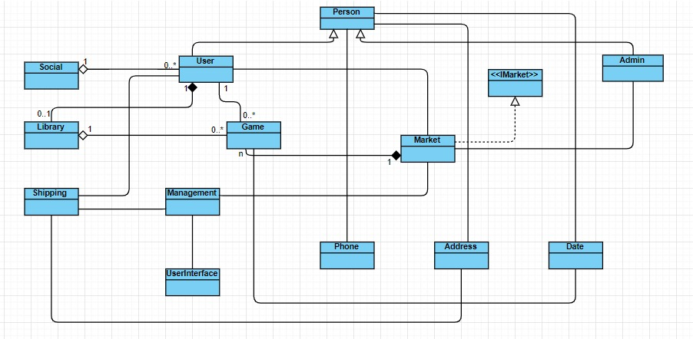
Diagram 1. Relations
Relations : In this diagram, classes are shown briefly without functions, methods and attributes. There is primarily one super class which is extended by User and Admin classes. Besides there is one Interface class (IMarket) which is implemented by Market and this Market class consists of n amount of games. Additionally each user has a friendlist and a game list which is called the Library.

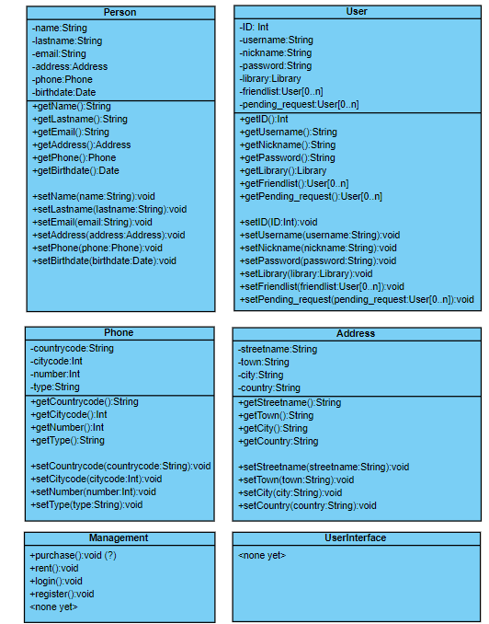
Diagram 2.1. Class Diagram 1
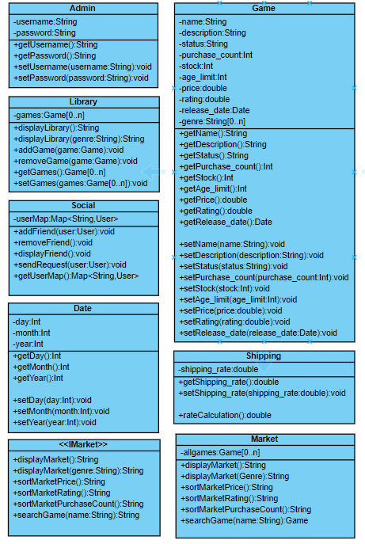
Diagram 2.2. Class Diagram 2
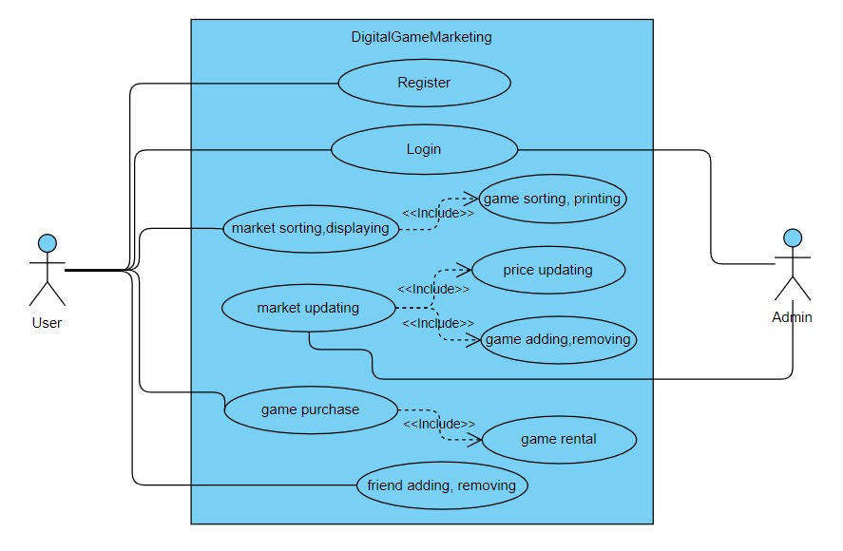
Diagram 3. Use Case
Use Case : User registers to the system initially, admin does not require any registration. Only after registration, login is possible for the user. The user can display, sort market and purchase or rent games. User can also add and remove friends. On the other hand, Admin has the permission to update prices, add game stocks to the market along.
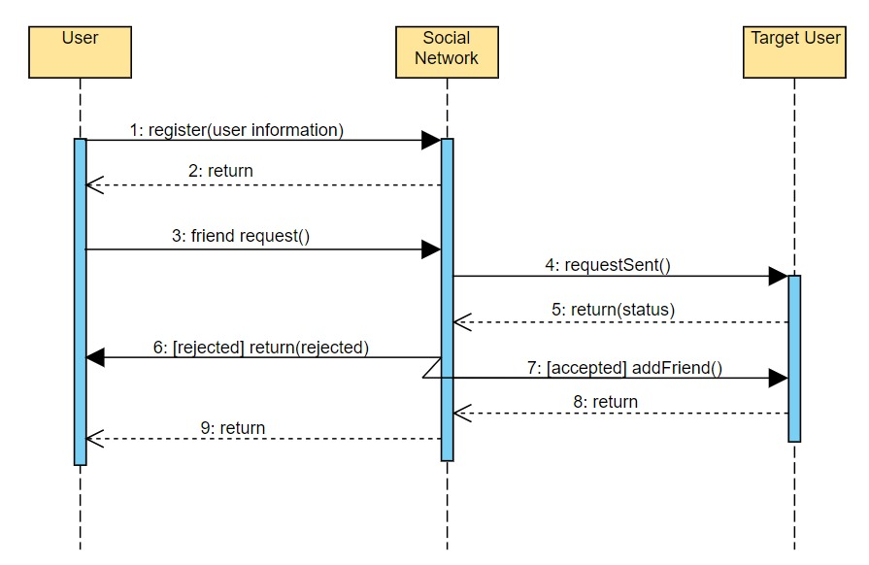
Diagram 4. Sequence Social Networking
Diagram 4 : This sequence diagram shows the process of the Social Network System. After a successful registration, the user also automatically signs up to the Social Network. The diagram only presents a “friending” action. A friend request is processed through the Social Network System (SNS), directed to the target user. After a response from the target user, it returns the status of the response. Based on the response, the pending request will be handled.
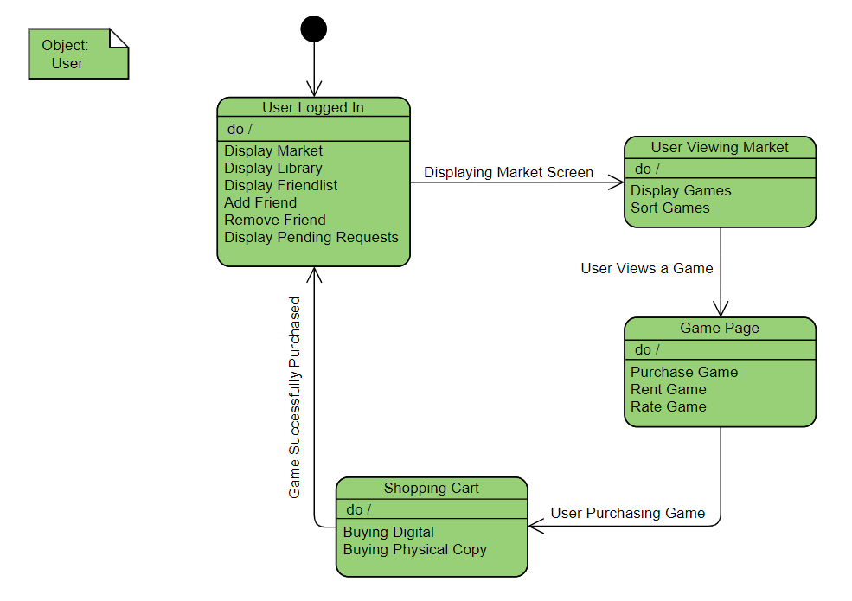
Diagram 5. Purchasing a Game State Chart
Diagram 5 : The diagram shows a successful purchase process. After a log in, in order to purchase a game, the user should display the market page first. After that the user can either display the entire market, sort the market or search for a game specifically. Once the game has found, the user can purchase or rent the game but can not rate unless it is already bought. If the user choses to purchase the game, it can be done in 2 ways: buying a digital key or a physical copy. If the game is successfully purchased and the transactions are made, the user will return to the main menu.
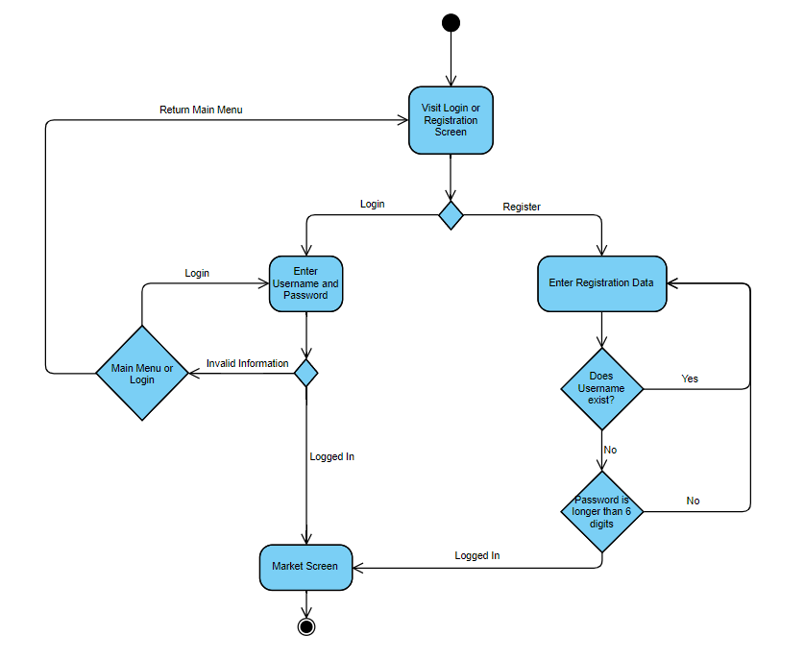
Diagram 6. Activity Diagram of Login Screen
Diagram 6 : After running the program, it initially starts from a login screen. Users can either login using their information or register to the system. If the user decides to login, it will require a username and a password. If an information is invalid, the user can decide whether to re-enter the information or return to the main login screen. If the user is not yet registered and chooses to sign up, a registration screen appears. The user have to submit registration data to the system in order to register successfully. If the chosen username already exists in the system, the program asks for a new username or the given password is less than 6 digits, the program naturally asks for a new password. After these processes, the user logs in to the system and a market screen appears.

CHAPTER FOUR

IMPLEMENTATION
In this chapter, the whole implementation style of the project will be discussed briefly along with some of the necessary details. While the project is not finished yet, it’s concluded vastly.
Before starting to the front-end design and implementation of the project, the crew had to ensure a viable way to fetch data. After a considerable time of discussing, the team decided to build a database structure which holds the relative data set of the project. Currently the optimal tool that would be proper to the current code design is .csv files. This is a vague idea at the first glance but the crew is open to new concepts.
The successful creation of a database structure brought a smooth extent to the project crew on which is more abundant to work on with. The initial file operations are completed successfully and it is a common belief amid the project team that these operations are concluded for good.
Although file operations were an important part of the project, a great part of the project was left unfinished. This functional part is mostly done except the GUI functions and the functions that’d require a GUI. However, the team can not foresee the necessities a GUI would bring hence, it is believed that additional functions and features may be implemented in the future.
A new functions that was also implemented is the cloning function. With this cloning feature, a big part of the encountered problems were eliminated. This feature mitigated the problem of object singularity. Whenever an object was added as a product, the upcoming changes altered the object everywhere in the project. With this cloning feature, the alteration only affects the desired object.
Also a dynamic queue model is implemented for the social platform part. This was a great aid to the social interactions such as like pending requests and adding friends.
As it was mentioned before, the crew encountered some issues about GitHub platform as well. While the problem was solved greatly, it still needs a bit more attention. Because of this problem, it became more obscure to be seen as a contributor. Even though the contribution part is not a problem among the team per se, for the project was created and designed togetherly, it is wished that this problem will be negated as soon as possible.
Another problem with the implementation was different usages of IDE’s between the project crew. Although it is not an issue to be concerned with, it’s worth mentioning for it was an obstacle at the first sight.
The previous shortness of the project has gotten rid of hugely. For the future part, the crew members aim to finish the project as a whole. An appealing and functioning GUI will be created, the code will be simplified and dynamically formatted. Along with these, a newly formatted project report will be created from scratch.

